PYTHON PROJECT

Name of the project : Strong Password Generator

**Creating a program that takes the length of the password as input and generates a random password of the same length. The strength of the password depends equally on the 4 properties mentioned below. If the password generated is in par with the conditions mentioned below then it is good otherwise it shouldn’t be taken into consideration.**

**Conditions to be taken into consideration while creating the code :**

* **Atleast 12 characters**
* A mixture of both uppercase and lowercase letters.
* A mixture of letters and numbers
* Inclusion of at least one special character, e.g., @ #?]

CODE :

import random

import string

print("Hello,welcome to password generator")

length=int(input("\nEnter the length of the password required: "))

lower=string.ascii_lowercase

upper=string.ascii_uppercase

num=string.digits

symbols=string.punctuation

all=lower+upper+num+symbols

temp = random.sample(all,length)

password= "".join(temp)

print(password)

Input of code in visual studio :

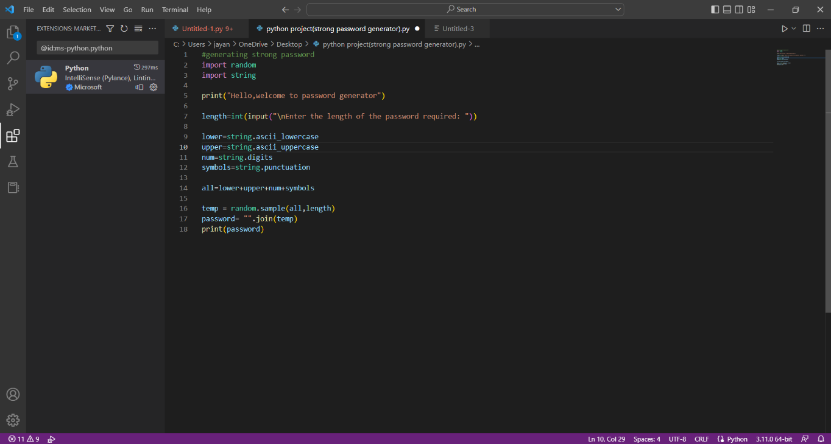

Output of Code after running :

